***Virginia Junior Classical League***

*presents this*

Certificate of Excellence

*to*

Lucie Baum

*of*

Manchester Middle

*for*

*1st Place in Dolls*

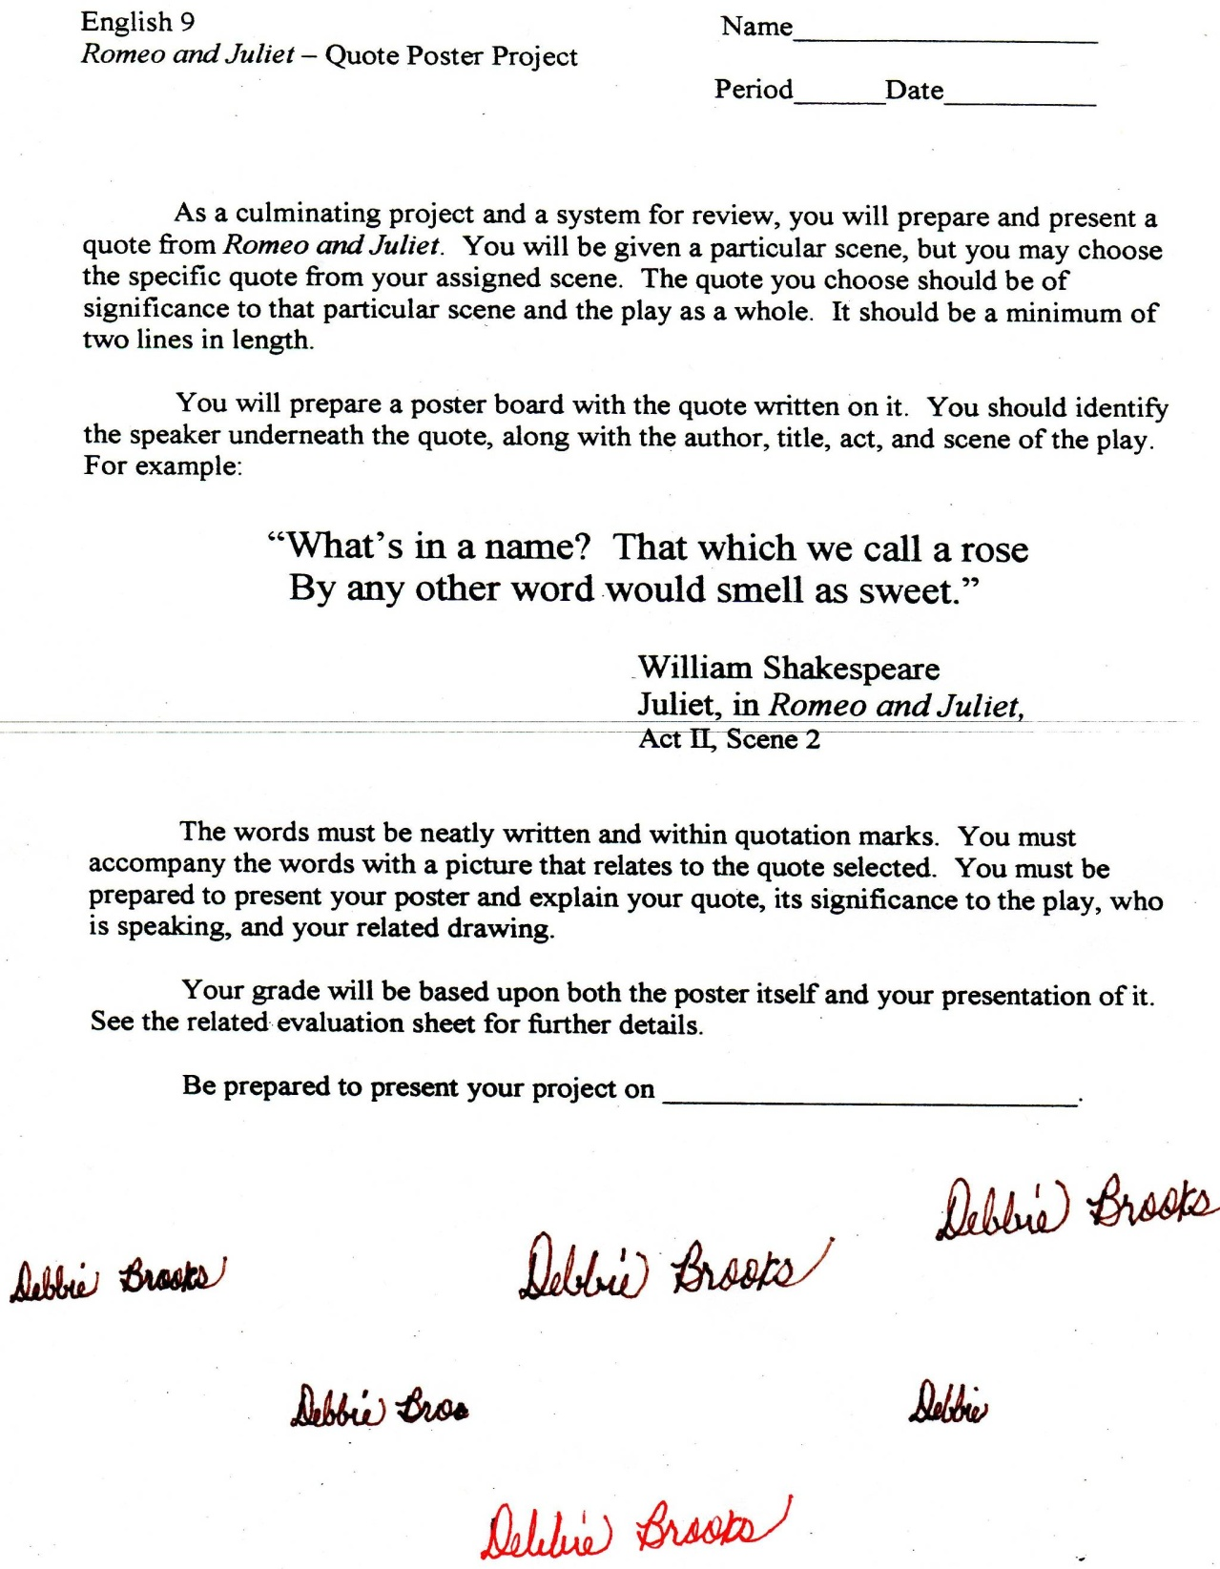

Microsoft Office Signature Line...

*a.d. viii Kal. Dec. MMDCCLXVII A.U.C. 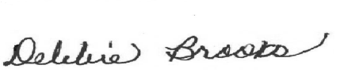*

***Virginia Junior Classical League***

*presents this*

Certificate of Excellence

*to*

Emma Levon

*of*

Manchester Middle

*for*

*1st Place in Jewelry*

**

Microsoft Office Signature Line...

*a.d. viii Kal. Dec. MMDCCLXVII A.U.C. *

***Virginia Junior Classical League***

*presents this*

Certificate of Excellence

*to*

Savanna Woods

*of*

Manchester Middle

*for*

*1st Place in Other*

**

Microsoft Office Signature Line...

*a.d. viii Kal. Dec. MMDCCLXVII A.U.C. *

***Virginia Junior Classical League***

*presents this*

Certificate of Excellence

*to*

Valerie Fortin

*of*

Manchester Middle

*for*

*2nd Place in Children's Book*

**

Microsoft Office Signature Line...

*a.d. viii Kal. Dec. MMDCCLXVII A.U.C. *

***Virginia Junior Classical League***

*presents this*

Certificate of Excellence

*to*

Riley Moffatt

*of*

Manchester Middle

*for*

*3rd Place in Dolls*

**

Microsoft Office Signature Line...

*a.d. viii Kal. Dec. MMDCCLXVII A.U.C. *

***Virginia Junior Classical League***

*presents this*

Certificate of Excellence

*to*

Paige Grunden

*of*

Manchester Middle

*for*

*3rd Place in Pencil*

**

Microsoft Office Signature Line...

*a.d. viii Kal. Dec. MMDCCLXVII A.U.C. *

***Virginia Junior Classical League***

*presents this*

Certificate of Excellence

*to*

Riley Moffatt

*of*

Manchester Middle

*for*

*5th Place in Mythology*

**

Microsoft Office Signature Line...

*a.d. viii Kal. Dec. MMDCCLXVII A.U.C. *

***Virginia Junior Classical League***

*presents this*

Certificate of Excellence

*to*

David Livingston

*of*

Manchester Middle

*for*

*5th Place in Sculpture*

**

Microsoft Office Signature Line...

*a.d. viii Kal. Dec. MMDCCLXVII A.U.C. *

***Virginia Junior Classical League***

*presents this*

Certificate of Excellence

*to*

Mark Autry

*of*

Manchester Middle

*for*

*6th Place in Maps*

**

Microsoft Office Signature Line...

*a.d. viii Kal. Dec. MMDCCLXVII A.U.C. *

***Virginia Junior Classical League***

*presents this*

Certificate of Excellence

*to*

Riley Moffatt

*of*

Manchester Middle

*for*

*10th Place in History*

**

Microsoft Office Signature Line...

*a.d. viii Kal. Dec. MMDCCLXVII A.U.C. *